**Exp No:1 HADOOP INSTALLATION**

**OUTPUT SCREENSHOTS:**

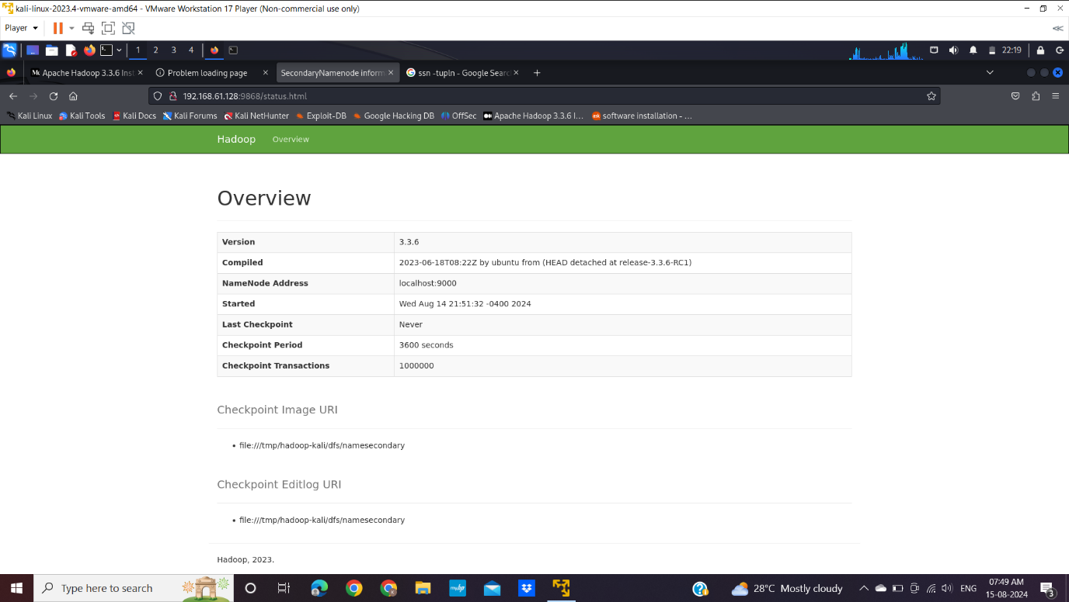

Fig 1: Secondary NameNode

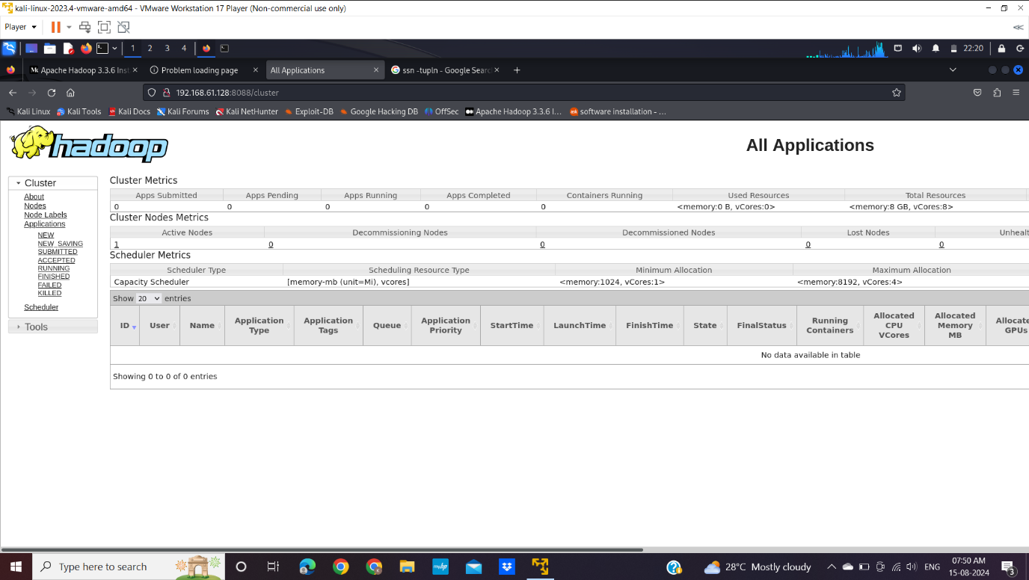

Fig 2:Hadoop Cluster